1. **one major goal of physics is the study of how an electric field can produce an electric force on a charged object**
2. A closely related goal is the study of how a magnetic field can produce a magnetic force on a (moving) charged particle or on a magnetic object such as a magnet
3. You may already have a hint of what a magnetic field is if you have ever attached a note to a refrigerator door with a small magnet or accidentally erased a credit card by moving it near a magnet
4. The magnet acts on the door or credit card via its magnetic field
5. The applications of magnetic fields and magnetic forces are countless and changing rapidly every year,
6. For decades, the entertainment industry depended on the magnetic recording of music and images on audiotape and videotape. Although digital technology has largely replaced…magnetic recording, the industry still depends on the magnets that control CD and DVD players and computer hard drives; magnets also drive the speaker cones in headphones, TVs, computers, and telephones
7. A modern car comes equipped with dozens of magnets because they are required in the motors for engine ignition, automatic window control, sunroof control, and windshield wiper control.
8. Most security alarm systems, doorbells, and automatic door latches employ magnets. In short, you are surrounded by magnets
9. The science of magnetic fields is physics; the application of magnetic fields is engineering. Both the science and the application begin with the question “What produces a magnetic field?”
10. What Produces a Magnetic Field?
11. Because an electric field is produced by an electric charge : , we might reasonably expect that a magnetic field is produced by a magnetic charge; (called magnetic monopoles); are predicted by certain theories, their existence has not been confirmed.
12. How then are magnetic fields produced? There are two ways.

:- One way is to use moving electrically charged particles, such as a current in a wire, to make an electromagnet. The current produces a magnetic field that can be used, for example, to control a computer hard drive or to sort scrap metal

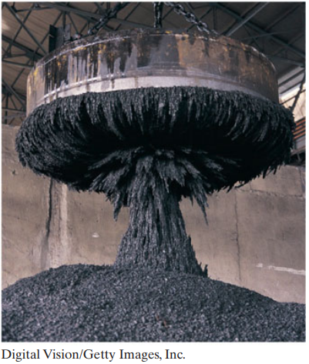

In Chapter 29, we discuss the magnetic field due to a current.

The other way to produce a magnetic field is by means of elementary particles such as electrons because these particles have an intrinsic magnetic field around them. That is, the magnetic field is a basic characteristic of each particle just as mass and electric charge (or lack of charge) are basic characteristics

As we discuss in Chapter 32, the magnetic fields of the electrons in certain materials add together to give a net magnetic field around the material.

Such addition is the reason why a permanent magnet, the type used to hang refrigerator notes, has a permanent magnetic field. In other materials, the magnetic fields of the electrons cancel out, giving no net magnetic field surrounding the material. Such cancellation is the reason you do not have a permanent field around your body, which is good because otherwise you might be slammed up against a refrigerator door every time you passed one

: Our first job in this chapter is to define the magnetic field . We do so by using the experimental fact that when a charged particle moves through a magnetic field, a magnetic force acts on the particle.

Moving Charged Particle

After many such trials we would find that when the particle’s velocity V is along a particular axis through the point, force **FB** is zero. For all other directions of V , the magnitude of **FB** is always proportional to v sin(x) , where x is the angle between the zero-force axis and the direction of V.

Furthermore, the direction of **FB** is always perpendicular to the direction of V. (These results suggest that a cross product is involved.)

**The Field.** We can then define a **magnetic field** B to be **a vector quantity** that is directed along the zero-force axis.

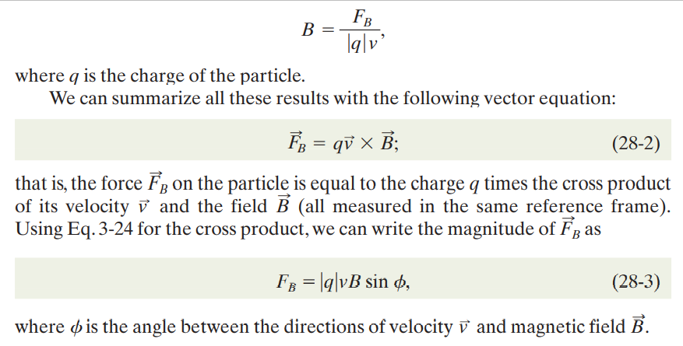We can next measure the magnitude of **FB** when V is directed perpendicular to that axis and then define the magnitude of B in terms of that force magnitude:

**Also give an example of velocity**

